**Department of Intelligence**

**Task**

Deciding that you need to stop Kory and his felonies, you turn to the Department of Defence and Intelligence to capture Kory at once but this isn't going to be an easy task. Kory change his location everyday in order not to be caught by you. Knowing this, you have to find a way to narrow down the places he goes to. You ask one of his friend, Aphelios, for help. She mapped out many of the locations that Kory usually goes to. You and the Department deploy informants and undercover agent to gather intel at those places. Now your job is to calculate the minimum time needed for intel to be delivered from those places back to the main headquarter.

These locations are indexed from 1 to N with 1 being the headquarter. These locations are connected by N-1 road which can be travel back and forth, each having a distance **di** km. There is a unique way to travel between any pair of towns without going through a town twice.

When Kory is found, an informant at that location will start delivering the information. Each informant is characterized by the amount of time required to start the journey and by his constant speed (expressed in minutes per kilometer) after departure.

The message from a location is always carried on the unique shortest path to the capital. Initially, the harbinger from the location where Kory is spotted carries the message. In each location that he traversed, the informant has two options: either go to the next location towards the HQ, or leave the message to the informant from this location. The new informant applied the same algorithm as above. Overall, a message could be carried by any number of informants before arriving in the HQ.

Your task is to find, for each location, the minimum time required to send a message from that location to the capital.

Input

The first line contains 

Each of the following 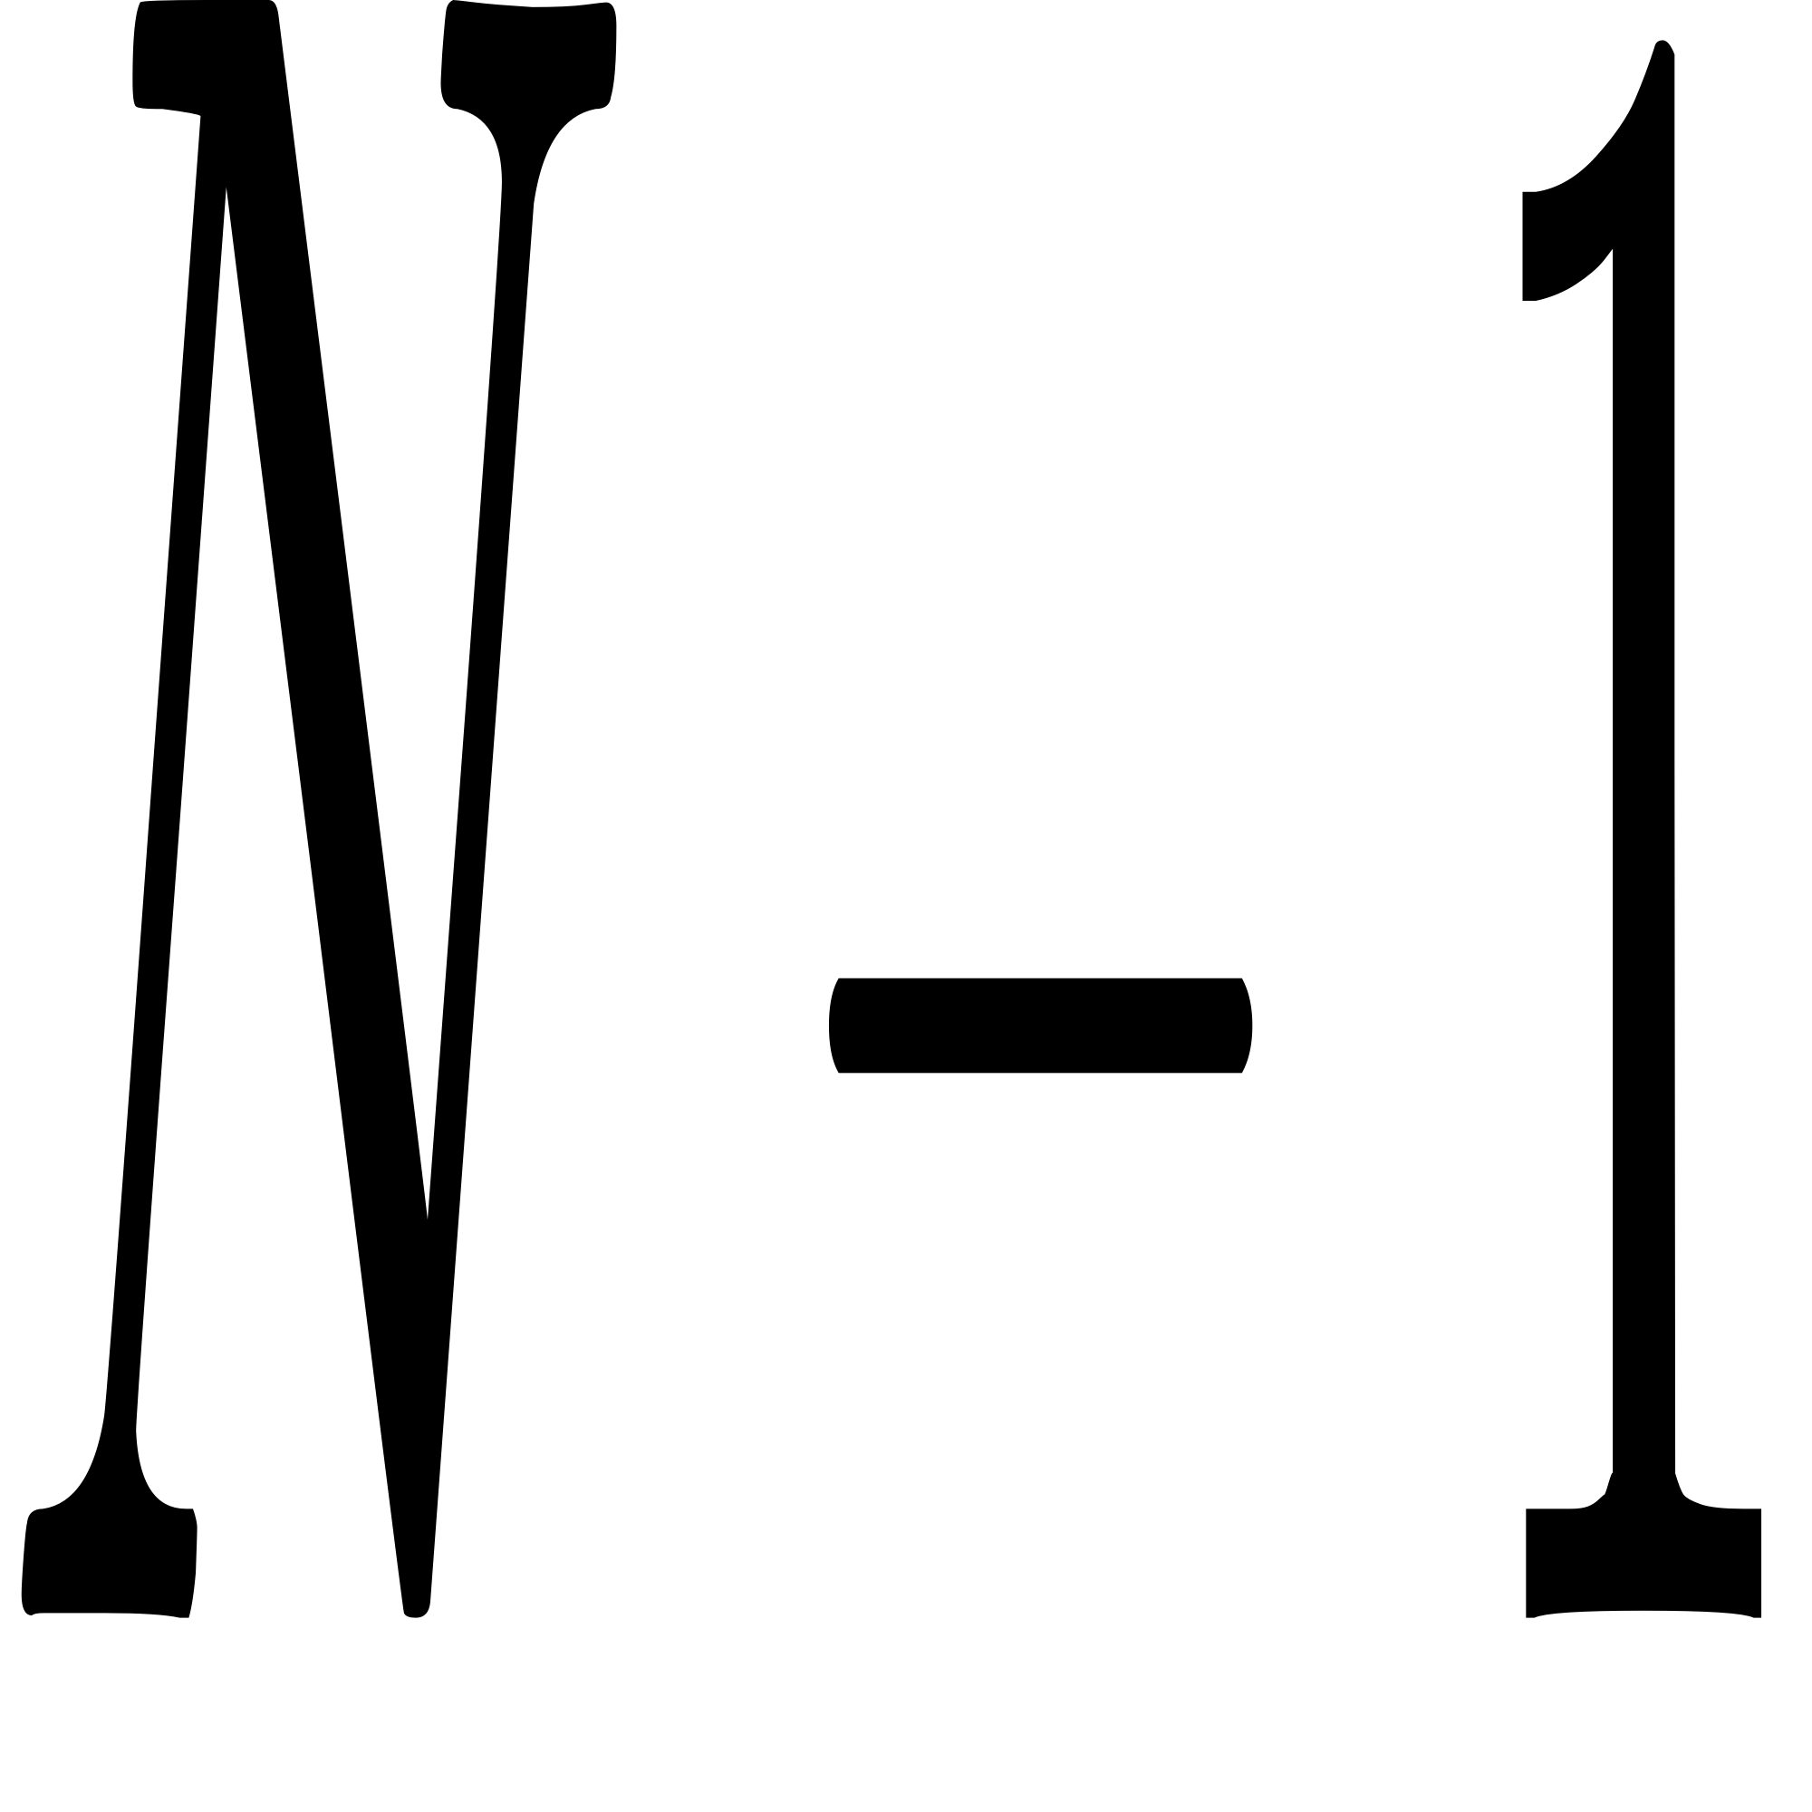 lines contains three integers wps seperated by one space, describing a road of length C:/Users/Kory/AppData/Local/Temp/wps.lEAyWRwps kilometers between towns numbered with C:/Users/Kory/AppData/Local/Temp/wps.OnqIWiwps and C:/Users/Kory/AppData/Local/Temp/wps.kfProlwps.

The next  lines contains pairs of integers  describing the characteristics of the informant at the i-th location. is the number of minutes to prepare for the journey, and C:/Users/Kory/AppData/Local/Temp/wps.hoJorwwpsis the number of minutes needed to travel one kilometer. There is no informant in the capital.

Output

A signle line containing  integers. The i-th number represents the minimum time, in minutes, required to send a message from the (i+1)-th town to the capital.

Constraints

• 3 wps N wps 100 000

• 0 wps Si wps wps

• 1 wps Vi wps wps

Sample

|  |  |
| --- | --- |
| Input | Output |
| 5  1 2 20  2 3 12  2 4 1  4 5 3  26 9  1 10  500 2  2 30 | 206 321 542 328 |